Tema 5

a)

declare

v_job_title jobs.job_title%type;

v_job_id jobs.job_id%type;

v_name employees.last_name%type;

v_salary employees.salary%type;

cursor job_cursor is

select distinct job_title, job_id

from jobs;

cursor employee_cursor(v_job_id jobs.job_id%type) is

select e.last_name, e.salary

from employees e

where e.job_id = v_job_id;

begin

open job_cursor;

loop

fetch job_cursor into v_job_title, v_job_id;

exit when job_cursor%notfound;

open employee_cursor(v_job_id);

dbms_output.put_line('Job: ' || v_job_title);

loop

fetch employee_cursor into v_name, v_salary;

exit when employee_cursor%notfound;

dbms_output.put_line('Angajat: ' || v_name || ', Salariu: ' || v_salary);

end loop;

close employee_cursor;

end loop;

close job_cursor;

end;

/

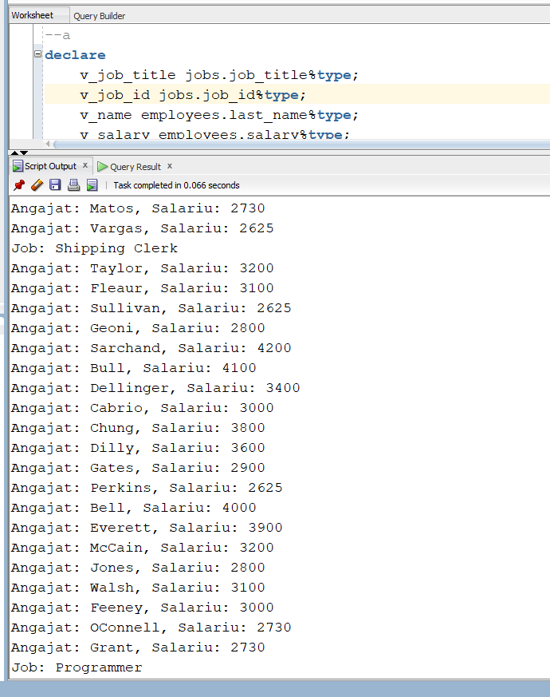

b)

declare

v_name employees.last_name%type;

v_salary employees.salary%type;

begin

for job_rec in (select distinct job_title, job_id from jobs) loop

dbms_output.put_line('Job: ' || job_rec.job_title);

for emp_rec in (select e.last_name, e.salary from employees e where e.job_id = job_rec.job_id) loop

dbms_output.put_line('Angajat: ' || emp_rec.last_name || ', Salariu: ' || emp_rec.salary);

end loop;

end loop;

end;

/

d)

declare

cursor job_cursor is

select job_title, job_id

from jobs;

cursor employee_cursor(p_job_id jobs.job_id%type) is

select last_name, salary

from employees

where job_id = p_job_id;

v_job_title jobs.job_title%type;

v_job_id jobs.job_id%type;

v_name employees.last_name%type;

v_salary employees.salary%type;

begin

open job_cursor;

loop

fetch job_cursor into v_job_title, v_job_id;

exit when job_cursor%notfound;

dbms_output.put_line('Job: ' || v_job_title);

open employee_cursor(v_job_id);

loop

fetch employee_cursor into v_name, v_salary;

exit when employee_cursor%notfound;

dbms_output.put_line('Angajat: ' || v_name || ', Salariu: ' || v_salary);

end loop;

close employee_cursor;

end loop;

close job_cursor;

end;

/